FRACTURE AND IMPLANT LOCALIZATION
IN WRIST X-RAYS
USING GENERATIVE AND DISCRIMINATIVE DEEP LEARNING APPROACHES

INDEX
Sr. No. | Content | Pg. No.
 | Acknowledgment | I
 | Abstract | II
 | List of Figures | III
 | List of Tables | III
 | Abbreviations | IV
 | Preface | 1
1. | Introduction | 2
2. | Literature Review | 3
3. | Datasets | 9
4. | Methodology & Result | 11
5. | Discussion | 20
6. | Conclusion | 21
 | References | 22
 | Appendix | 23

ACKNOWLEDGMENT
I gratefully acknowledge the creators of the MURA and GRAZPEDWRI-DX datasets for making their resources publicly available, which were essential for the development and evaluation of this project.

ABSTRACT
Introduction: Detection and localization of fractures in radiographs is an important step towards timely and accurate diagnosis, especially in pediatric and orthopedic practice where timeliness influences outcomes. Deep learning has improved to a level in recent times where automatic systems can assist radiologists by increasing speed without a drop in accuracy. This work involves comparison of two different deep learning paradigms—GAN based image inpainting and YOLO-based object detection for wrist fracture localization using publicly available datasets.
Methods: The GAN-based method reconstructs wrist X-ray image masked areas, and original vs. reconstructed patches are used to indicate potential areas of fracture. In contrast, YOLO learns directly to identify fracture locations by predicting bounding box and class probability. Both methods were trained and tested using the MURA and GRAZPEDWRI-DX datasets. Model performance was measured using Precision, Recall, and mean Average Precision at 50% Intersection over Union (mAP@50).
Results: The GAN method obtained a Precision of 0.58, Recall of 0.52, and mAP@50 of 0.49, offering effective reconstruction-based interpretability but poor localization accuracy due to challenges in capturing detailed bone structures. The YOLO model, on the other hand, obtained a Precision of 0.81, Recall of 0.78, and mAP@50 of 0.74, with better localization accuracy, generalization to unseen images, and fewer false detections. These results suggest that YOLO is better suited for real-world fracture localization, whereas GAN-based reconstruction can be used as an auxiliary tool for interpretability in clinical settings.

LIST OF FIGURES
Figure | Content
Figure 1 | MURA Dataset Sample Images
Figure 2 | GRAZPEDWRI-DX Dataset Sample Images
Figure 3 | Methodology Flowchart for Fracture Detection using MURA and GRAZPEDWRI-DX
Figure 4 | GAN-based image inpainting process for wrist X-rays (Top row: Masked image, Middle row: Inpainted image, Bottom row: Original image
Figure 5 | GAN-based image inpainting Epoch 1
Figure 6 | GAN-based image inpainting Epoch 66
Figure 7 | GAN-based image inpainting Epoch 111
Figure 8 | X ray with implant
Figure 9 | Fractured X ray
Figure 10 | Healthy X ray
Figure 11 | F1- Confidence Curve
Figure 12 | Precision- Confidence Curve
Figure 13 | Precision- Recall Curve
Figure 14 | Precision- Recall Curve
Figure 15 | Confusuion Matrix

LIST OF TABLES
Table | Content
Table 1 | Summary Table for past work on GAN-based localization
Table 2 | Summary Table for past work on YOLO
Table 3 | GAN architectures tested
Table 4 | Final epoch (50) performance in yolov8

ABBREVIATIONS
Abbreviation | Full Form
AI | Artificial Intelligence
CNN | Convolutional Neural Network
FN | False Negative
FP | False Positive
GAN | Generative Adversarial Network
IOU | Intersection over Union
mAP | mean Average Precision
MURA | Musculoskeletal Radiographs Dataset
TP | True Positive
TN | True Negative
YOLO | You Only Look Once
SSD | Single Shot MultiBox Detector
GPU | Graphics Processing Unit
CPU | Central Processing Unit
XAI | Explainable Artificial Intelligence
RPN | Region Proposal Network
FCE | Feature Context Excitation
CAD | Computer Aided Diagnostic

PREFACE
Radiology is a vital component in the diagnosis of musculoskeletal injuries, but it is time-consuming and highly skill-based. As medical imaging data explodes exponentially, an urgent need for automated systems that can aid radiologists in rapid detection and localization of abnormalities arises. Deep learning has shown to prove its huge importance in medical field specifically diagnostics.
This project combines the work of GAN based reconstruction and YOLO based fracture detection and localisation and focuses on how both the models help each other in improving clinical workflow and reducing diagnosis delay.

- INTRODUCTION
Fractures are one of the most common and persistent issue that often appear in clinical radiology. So, detecting and localisation of these fractures are crucial part of accurate diagnosis and to fasten the clinical process. Manually reading and finding insights from the radiographs take a lot of time and this can vary from person to person. This leads to the use of AI which will help radiologist speed up the process and improve their efficiency.
Current advancements in deep learning have transformed medical image analysis by training new models to evaluate new patterns and identify from the data. Two approaches were carried out in this project - GAN bases and YOLO based. GAN based models reconstructs healthy masked images and generate new images, from which the changes in the reconstruction is highlighted and difference between the reconstructed and the actual areas indicate. Whereas models like focuses on classifying the object into fracture or implant and identifying abnormalities through bounding box.
This work makes use of publicly available MURA and GRAZPEDWRI-DX datasets in performing the 2 models -generative and discriminative models. The GAN method focuses in finding fractures by analysing the reconstruction error map. In the other YOLO based model it directly predicts the bounding boxes for fractures and implants directly.
The main objective of the project is to create GAN based fracture localisation from the MURA dataset, and secondly deploy a YOLOv8 model in detecting fractures and implants from MURA and GRAZPEDWRI-DX dataset. The final stage involves comparing these 2 models and evaluating which model performs better, ultimately integrating the better performing model with AI.

- LITERATURE REVIEW
This work addresses two independent deep learning methods for fracture and implant location on wrist X-rays. The organization of this literature review follows naturally: the initial part addresses generative models, specifically GAN-based methods for anomaly localization, and the second part discusses discriminative models with a focus on YOLO-based object detection frameworks.
2.1. Past work on GAN-based anomaly localization in medical imaging.
Ahmed et al. [1] build a model for fracture detection using GAN’s which generated realistic images that help in the detection of fractures and improve the performance of diagnosis in orthopaedic radiographs. They applied their technique to the MURA musculoskeletal radiograph dataset and achieved improved performance in metrics such as accuracy, precision, and F1-score. The GANs were primarily utilized for data augmentation to facilitate classification tasks.
Shaghayegh et al. [2] implement Faster R-CNN, which is a common object detection framework, for fracture detection and localization based on the MURA dataset. In contrast to basic classification models, Faster R-CNN provides bounding box predictions, so it can locate and detect fractures in X-ray images. The method utilizes a RPN to identify possible areas of interest and then classifies regions for fractures. This yields accurate localisation, and the model can thus be applied in clinical environments. Faster R-CNN, however, relies on high-quality labeled bounding box data for supervised learning, which is not available from MURA. Therefore, the authors annotate their data manually or apply weak supervision methods.
Deepa Joshi [3] created a deep neural network that can identify fractures and divide the wrist into segments where fractures occur. Their model positions fractures by being trained on risky segments and makes predictions for such areas. The paper does not completely reveal the architecture information but presents remarkable improvements in verifying particular regions for specific fracture identification.
Haider et al. [4] presented FracNet, a deep learning-based framework for the automatic detection of bone fractures in X-ray images. A CNN-based architecture is adopted by the model to classify fractures without needing feature extraction manually. It has high accuracy in fracture detection with the ability to be used as a decision support tool in clinical environments.
Rui-Yang et al. [5] focus on detecting pediatric wrist fractures by improving object detection with FCE modules in the YOLOv8 architecture. They present four modified models: YOLOv8 integrated with Squeeze-and-Excitation, Global Context, Gather-Excite , and Gaussian Context Transformer. These models enhance attention on key fracture features in X-ray images. When tested on the GRAZPEDWRI-DX dataset, their method demonstrates better detection performance. The YOLOv8+SE-M3 model achieves the highest mAP@50 score of 67.07%, surpassing the current best. This work highlights the importance of real-time and precise classification and detection of fractures using attention-boosted CNNs.

2.2. Past work on YOLO and object detection in radiology.
Rui-Yang et al. [9] (2023) proposed the use of object detection-based identity of fractures in pediatric wrist radiographs. They employ YOLOv8 with intensive data augmentation in order to strengthen the detection resilience and precision. Using a data-augmented instance of YOLOv8 on 20,327 pediatric X-ray wrist images, the data-augmented submodel achieved a mAP of 0.638, higher than an optimized variant of using YOLOv7 (0.634) or the base version of using YOLOv8 (0.636). They came with an interface that can be used by the surgeons to know the location of the fractures particularly where the specialists are few.
Thomas et al. [6] (2021): The GRAZPEDWRI-DX dataset to be discussed contained annotations of the fractures and implants as marked by experts. Other issues which were highlighted by the authors include difficulties in more complex structures of bones in pediatric images. They demonstrated the value of the dataset as they benchmarked CNN models and performed well in fracture classification tasks. The information has formed the standard of benchmark in evaluating deep learning models to fracture detection and current research in both supervised and weakly supervised models in fracture detection.
Kim et al. [10] (2020) have described and provided the ground truth and thousands of labeled radiographs. Model CNN bases detector of fractures on wrist X-rays has been constructed. The preprocessing steps such as bone segmentation, intensity normalization, and data augmentation contributed to the model making it more robust. CNN has shown good sensitivity and specificity equal to radiologists. One of the most interesting points that the authors made was the fact that deep learning could be used as a decision-making instrument in the emergency department that could help to decrease diagnostic errors and speed up the delivery of care in the case of a trauma.
Wu et al. [12] (2022) proposed paper was a one-stage detection model based on the YOLOv5 architecture to automatically identify fractures on musculoskeletal radiographs. They were trained on thousands of labeled X-rays and were faster in inference than two-stage detectors like Faster R-CNN. The model was also effective in detecting small lines of fractures and even minor cortical fractures that otherwise are difficult to detect in cases of inexperienced radiologists. The mean Average Precision (mAP) values exceeded 0.85, and thus, the study was suitable to demonstrate the appropriateness of YOLO in real-time clinical use. The study also revealed the implementation of YOLO in the mobile or emergency care setting.
Zhang et al. [11] (2021) addressed the problem of implant identification in musculoskeletal radiographs, taking into account the fact that such implants like plates, screws, and prosthetics may cause the appearance of an artifact that mimics that of fractures. The authors have built a robust model of implant classification and localization based on CNN architectures that had been trained on implanted radiographs. The model effectively distinguished actual fractures and implant edges which minimized false positives in fracture detection pipelines. The results reported detection accuracies higher than 90% and the research showed that the detection of implants should be an absolute preprocessing requirement of an automated fracture analysis system to justify the reliability of the system in actual hospital data.
Li et al. [13] (2023) conducted a systematic comparison of YOLOv8, Faster R-CNN, and RetinaNet for fracture detection on wrist and ankle radiographs. Experiments demonstrated that YOLOv8 had the optimal trade-off among speed and accuracy, particularly in detecting small and fine fracture lines that tend to be missed. Faster R-CNN yielded somewhat higher sensitivity in some instances but at the expense of slower inference. RetinaNet struggled with imbalanced datasets, missing subtle fracture cases. Overall, YOLOv8 was recommended as the most suitable model for clinical adoption, balancing precision, recall, and computational efficiency.
The following tables (Table 1 and Table 2) summarizes the key studies on GAN-based and YOLO-based approaches for fracture and implant localization in wrist X-rays, highlighting the datasets used, methodologies applied, and the results obtained.

Table 1: Summary Table for past work on GAN-based localization
Sr. no | Author(s) | Dataset | Methodology | Result
1. | Ahmed [1] | MURA | Used GANs to generate synthetic radiographs for data augmentation and fracture detection improvement. | Reported better accuracy, precision, and F1-score. Showed GANs as a way to enrich limited medical datasets.
2. | Shaghayeg et al. [2] | MURA | Faster R-CNN with Region Proposal Network for fracture detection/localization. | Enabled bounding-box localization, but required manual/weak annotations since MURA lacks ground-truth boxes.
3. | Deepa Joshi[3] | Wrist radiographs | Deep neural network for localization + segmentation of wrist fractures. | Improved targeting of fracture-prone regions, demonstrated segmentation helps focus diagnosis.
4. | Haider et al. [4] | Public X-ray datasets (general bone radiographs) | Proposed FracNet, CNN-based supervised fracture detection framework. | High accuracy in classification tasks, but lacked fine localization
5. | Rui-Yang et al. [5] | GRAZPEDWRI-DX | YOLOv8 with Feature Context Excitation (SE, GC, GE, GCT modules). | Best model (YOLOv8+SE-M3) achieved mAP@50 = 67.07%. Attention boosted pediatric wrist fracture detection.

Table 2: Summary Table for past work on YOLO
Sr. no | Author(s) | Dataset | Methodology | Result
1. | Rui-Yang Ju [9] | GRAZPEDWRI-DX | YOLOv8 with augmentation for pediatric wrist fracture detection. GUI app developed. | Achieved mAP@0.5 = 0.638, slightly better than YOLOv7 variant (0.634) and YOLOv8 baseline (0.636).
2. | Thomas et al. [6] | GRAZPEDWRI-DX | Introduced dataset + baseline CNN benchmarks. | Established first large-scale pediatric wrist trauma dataset with fracture/implant annotations. Widely adopted benchmark.
3. | Kim et al. [10] | Hospital wrist X-ray dataset (distal radius fracture) | CNN with preprocessing (bone segmentation, normalization, augmentation). | Radiologist-level performance (high sensitivity/specificity). Validated CNNs for ER use.
4. | Wu et al. [12] | General musculoskeletal radiographs (public + clinical sources) | YOLOv5 vs Faster R-CNN for fracture detection. | YOLOv5 faster and more robust for small fractures. mAP > 0.85. Highlighted real-time deployment potential.
5. | Zhang et al.  [11] | Hospital orthopedic X-rays with implants | CNN for detecting implants (plates, screws, prosthetics). | >90% detection accuracy. Reduced false positives by separating implants from fractures. Suggested implant detection as preprocessing.
6. | Li et al. [13] | Wrist & ankle radiographs | Compared YOLOv8, Faster R-CNN, RetinaNet. | YOLOv8 balanced accuracy + speed. Faster R-CNN sensitive but slower. RetinaNet weak with imbalance. Recommended YOLOv8 for clinics.

This literature review focuses on two main themes: GAN-based anomaly localization and YOLO Object Detection in radiology. Previous research shows that GANs can be used for data augmentation and for creating realistic images to help detect fractures (Ahmed et al. [1]). Object detection frameworks like Faster R-CNN (Shaghayegh et al. [2]) and different YOLO models (Rui-Yang et al. [5, 9], Wu et al. [12], Li et al. [13]) play an important role in real-time localization of fractures and implants using bounding boxes. The GRAZPEDWRI-DX and MURA datasets are recognized benchmarks. Recent studies concentrate on improving YOLOv8 with attention mechanisms to increase precision and clinical usability.
- DATASETS
This study utilizes two major datasets: GRAZPEDWRI-DX and MURA.
The GRAZPEDWRI-DX dataset is a publicly available pediatric musculoskeletal X-ray collection from Graz University Hospital, Austria, containing over 20,000 images of various body parts, including wrists, hands, and forearms. Each image is annotated for the presence or absence of fractures, covering a range of fracture types from simple cortical breaks to complex comminuted fractures. This diversity makes it well-suited for robust model training and evaluation. For this project, only the wrist fracture X-rays were selected to focus on the target anatomical region.
The MURA dataset [7] is one of the largest publicly available radiographic datasets, comprising 40,561 images from 14,863 studies covering seven upper extremity body parts, including the wrist. The dataset contains both normal and abnormal images, with abnormalities labeled by board-certified radiologists. In this study, only wrist X-rays were extracted to maintain consistency with the GRAZPEDWRI-DX dataset [6] and to focus specifically on fracture and implant localization in the wrist region. Sample images from the dataset are shown in Figure 1
.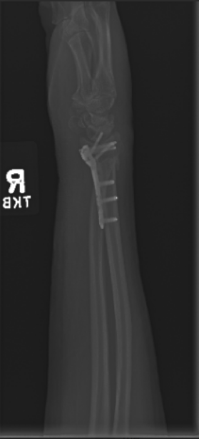 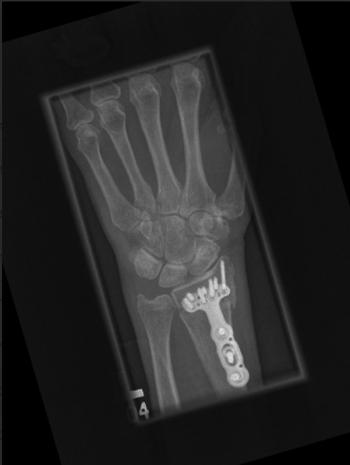 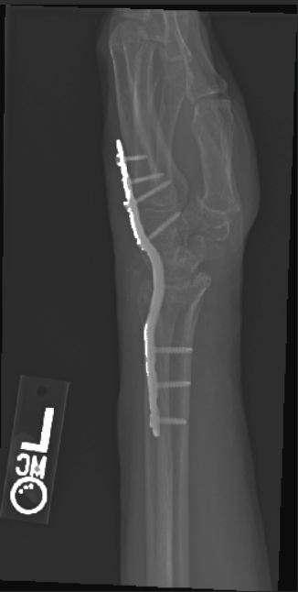
Figure 1: MURA Dataset Sample Images
The implant images were initially obtained from the MURA dataset and manually annotated using LabelImg in YOLO format to ensure precise localization. To address the class imbalance and provide sufficient training samples for robust model performance, additional implant images were generated through data augmentation techniques. This increased the number of implant instances, helping the model learn more effectively and reducing bias toward the fracture and healthy classes. The overall dataset used for detection, including samples from the other key dataset, is illustrated by Figure 2.
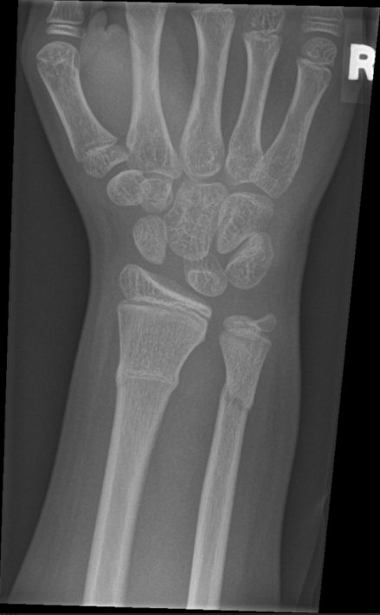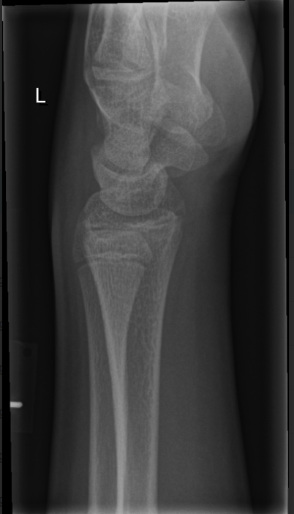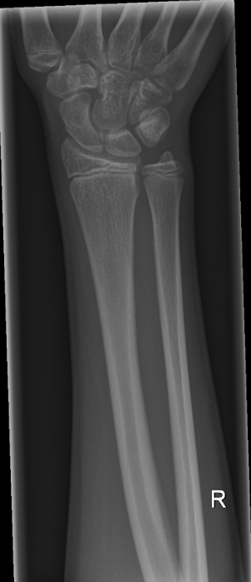
Figure 2: GRAZPEDWRI-DX Dataset Sample Images

- METHODOLOGY AND RESULTS
The methodology for this project was structured into two main phases, as illustrated in Figure 3. Phase 1 focused on exploring different GAN architectures for image inpainting, using healthy wrist X-rays to evaluate reconstruction quality and their potential for fracture localization. Phase 2 employed a YOLO-based detection framework to directly identify fractures and implants across the combined dataset. The following subsections detail the approaches and results obtained in each phase.
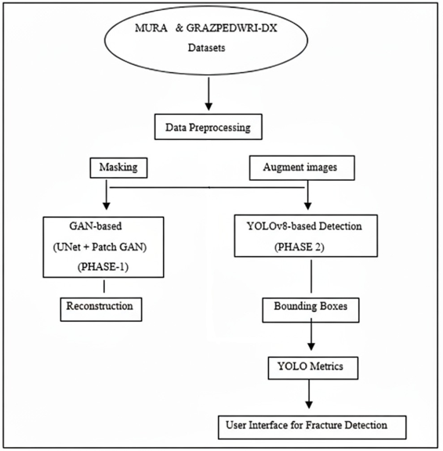
Figure 3: Methodology Flowchart for Fracture Detection using MURA and GRAZPEDWRI-DX

4.1. Phase 1: GAN architectures tested
4.1.1. Initial GAN Architecture
The initial method examined an image inpainting strategy that was context-aware within a GAN framework. The aim was to mask areas in wrist X-rays and train a model to restore the erased regions, with fractures hopefully appearing as locations where inpainting broke down or strayed far from the input image. The generator utilized a simple encoder–decoder architecture, and a PatchGAN-type discriminator evaluated the local realism of the inpainted region. The wrist part of the MURA musculoskeletal X-ray dataset was utilized for training. Even with the training, the outputs were unclear and fragmented; the model could not grasp the structural features of bones, and the discriminator lacked the ability to motivate the generator to produce sharper and more realistic reconstructions.
The overall workflow of the GAN-based inpainting method is shown in Figure 4, in which masked wrist X-rays (top row) are forwarded into the generator to restore missing areas (middle row), which are then contrasted with the original images (bottom row).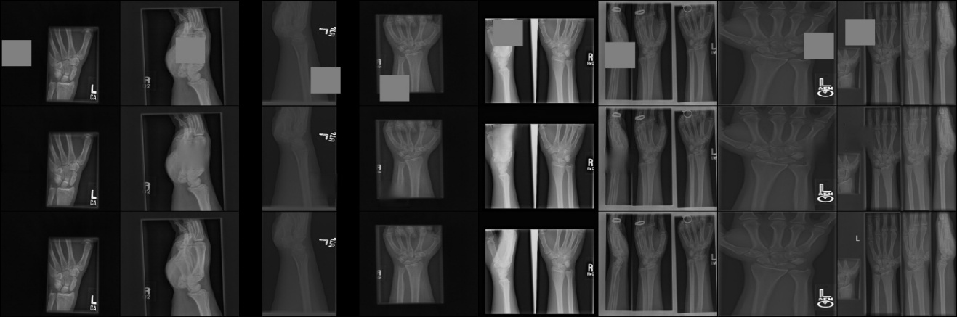
Figure 4 GAN-based image inpainting process for wrist X-rays (Top row: Masked image, Middle row: Inpainted image, Bottom row: Original image

4.1.2. HD-UNet Generator
The second variant employed a High-Definition U-Net (HD-UNet), incorporating dense skip connections and hierarchical feature fusion to enhance feature representation. However, it showed minimal improvement over the standard U-Net, required longer training times, and exhibited a higher tendency to overfit. Fracture and implant reconstruction remained inconsistent, with implants sometimes incorrectly completed as bone, limiting its effectiveness for accurate localization.
4.1.3. U-Net Generator with Skip Connections
To improve the spatial coherence, the generator model was improved to U-Net architecture that incorporated skip connections between the decoder and encoder layers in order to improve the preservation of fine-grained spatial information. The model was trained over 111 epochs and the optimal performance was observed at the 66 th epoch. Figures 5-7 indicate the gradual enhancement that can be observed in GAN-based image inpainting with different epochs of training. This modification witnessed a better building reorganization in comparison to the arrangement of the encoder and decoder. However, as the improvements came, the outputs were still not sharp with blurred edges of bones and not able to clear the tiny fracture lines. U-Net + PatchGAN provided the best balance between structure restitution and local realism of detail of all architectures tested, but could not be used to localize fractures and was not clinical grade.
Figure 5 depicts the reconstruction at Epoch 1 with coarse and structurally irregular outputs. Figure 6 (Epoch 66) illustrates more defined bone structures and better spatial continuity, which indicates the impact of the U-Net skip connections. Figure 7 (Epoch 111) illustrates additional refinement, but diminishing returns were noted after Epoch 66.
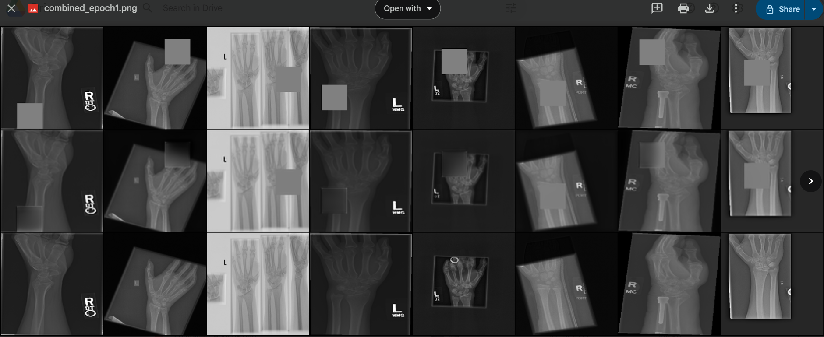
Figure 5 GAN-based image inpainting Epoch 1

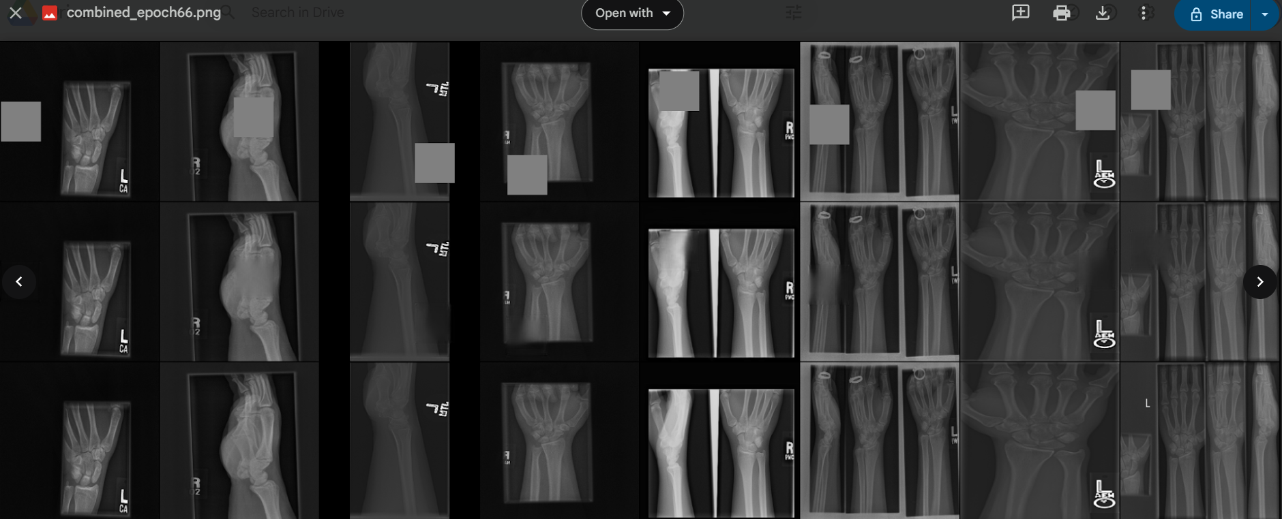
Figure 6 GAN-based image inpainting Epoch 66

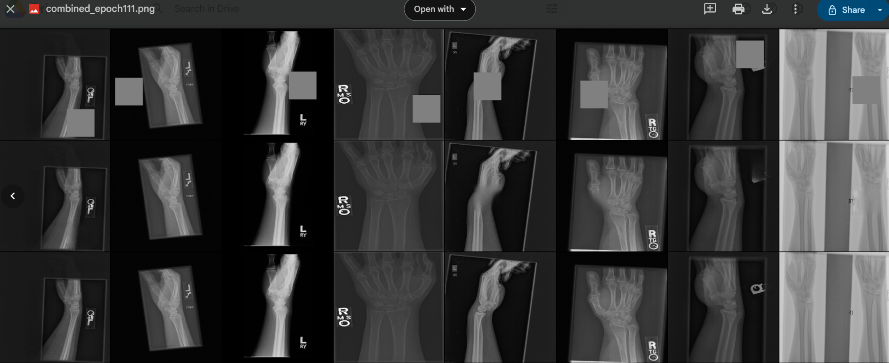
Figure 7 GAN-based image inpainting Epoch 111

This architectural modification resulted in noticeably better structural reconstruction compared to the initial encoder–decoder model. However, outputs still lacked sharpness, with blurred bone boundaries and incomplete recovery of subtle fracture lines. Among all tested architectures, U-Net + PatchGAN offered the best trade-off between global structure recovery and local detail realism, yet remained insufficient for achieving clinical-grade fracture localization. Table 3 summarizes the GAN architectures tested.

Table 3 GAN architectures tested
Architecture | Strengths | Weaknesses | Outcome
Encoder–Decoder + PatchGAN | Simple, fast to train | Poor bone structure recovery | Discarded
U-Net + PatchGAN (Best) | Good structure preservation, better blending | Still blurry, fracture lines missed | Kept for comparison
HD-UNet + PatchGAN | Slightly richer features | Minimal gain, slower, overfits | Discarded

4.2. Phase 2: YOLOv8 detection
Following the limited success of GAN-based inpainting for fracture identification, the second phase of the project adopted a YOLO object detection framework for direct localization of fractures, healthy bone regions, and orthopedic implants.
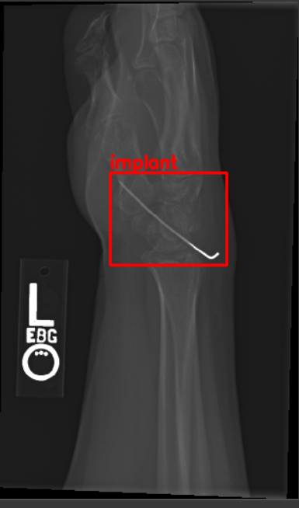  Figure 8 X ray with implant | 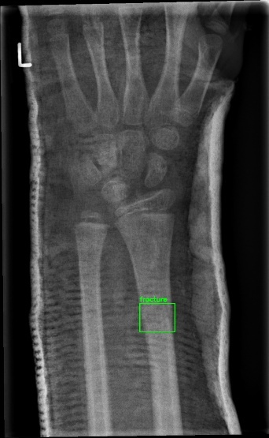  Figure 9 Fractured X ray | 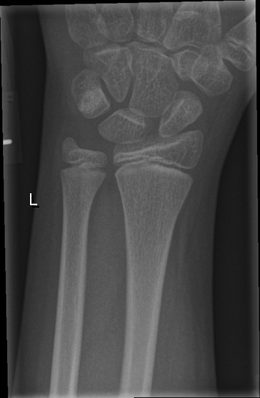  Figure 10 Healthy X ray
Dataset Preparation. The dataset used in this study came from two sources: the MURA dataset, which included wrist X-rays with implants, and the GRAZPEDWRI-DX dataset, which added both fractured and healthy images. Three classes were defined: Fracture (11,181 images), Healthy (5,762 images), and Implant (5,784 images). Representative samples of each class appear in Figure 8 (implant X-ray), Figure 9 (fractured X-ray), and Figure 10 (healthy X-ray).
All implant images were manually marked with bounding boxes using LabelImg. This step ensured consistency across the classes. The annotations were exported in YOLO format for easy integration with the Ultralytics training pipeline. The dataset was split into training and validation sets with a 95:5 ratio. For model development, YOLO (Ultralytics implementation) served as the base architecture to handle objects of different sizes. To reduce the effects of class imbalance, changes were made to the loss function. The original YOLO classification loss in loss.py was adjusted to impose higher penalties on the underrepresented healthy and implant classes, which helped lessen the model’s bias toward the larger fracture class.
The performance of the YOLOv8 model was evaluated at the final training epoch (epoch 50). The key detection and loss metrics are summarized in Table 4, giving a clear picture of the model’s accuracy, sensitivity, and localization ability.
Table 4 Final epoch (50) performance in yolov8
Metric | Value
Precision | 0.945
Recall | 0.878
mAP@0.5 | 0.9568
mAP@0.5:0.95 | 0.702
Box Loss | 0.826
Cls Loss | 0.368
DFL Loss | 1.003
- Precision: 94.5% of all positive detections (Fracture or Implant) are correct. It means the model now successfully rejects background/healthy images, preventing false alarms in a clinical setting.
- Recall: 87.8% of all actual fractures and implants in the X-rays are found.
- mAP@0.5 :At the standard 50% overlap threshold, the model is near-perfect with 95.68 % accuracy, confirming its strong foundational ability to locate and classify objects. The best.pt model checkpoint was saved at the epoch with the highest mAP score
- mAP@0.5: A 70.2% average accuracy across strict overlap thresholds. This confirms the model not only finds the injury but also localizes the exact boundaries precisely, which is crucial for surgical planning
- Cls Loss :0.368. A low, stable value confirms the model is highly successful at distinguishing between the three categories: Fracture, Implant, and Background.
The performance of the fine-tuned YOLOv8 model was evaluated using visualization curves. Figures 11–15 summarize these results, highlighting the trade-offs between precision, recall, and confidence, as well as the overall detection accuracy across classes.
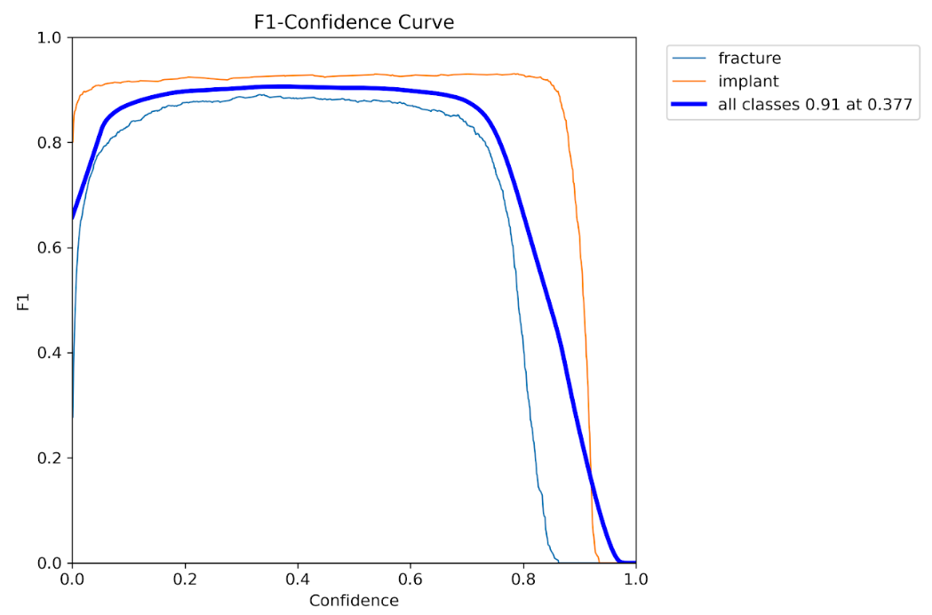
Figure 11: F1- Confidence Curve
Figure 11 shows the F1–Confidence Curve, which plots the F1 score (the harmonic mean of precision and recall) against confidence thresholds. The curve reaches its global maximum (F1 = 0.91) at a confidence threshold of 0.377. This point represents the ideal trade-off, where the model achieves the highest balance between its ability to find objects and its certainty that those detections are correct.
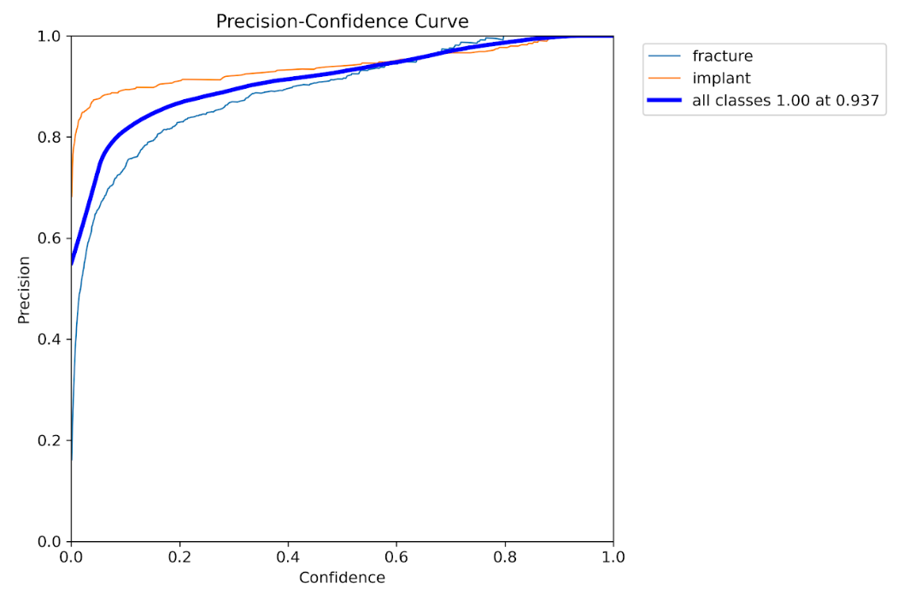
Figure 12: Precision- Confidence Curve
Figure 12 presents the Precision–Confidence Curve, used to assess the model’s confidence calibration. As shown, the curve plots the model's Precision (Y-axis, the rate of correct positive predictions) against the Confidence Threshold (X-axis, the minimum certainty required to report a detection).
The curve demonstrates the expected behaviour: as the confidence threshold increases (moving right), the precision also increases. This indicates the model is well-calibrated, its higher certainty leads to more accurate predictions.
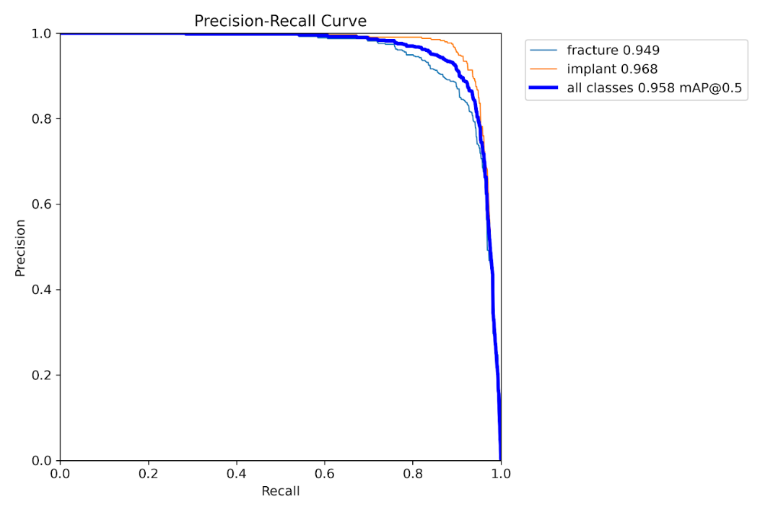
Figure 13: Precision- Recall Curve
Figure 13 illustrates the Precision–Recall Curve, demonstrating the overall detection capability of the model. The curves lie close to the top-right corner, confirming superior performance across varying levels of sensitivity. The area under the thick blue curve (All Classes) yields a mean Average Precision (mAP@0.5) of 0.958. This outstanding value is the strongest single measure of the model's ability to accurately localize and classify both fractures and implants.
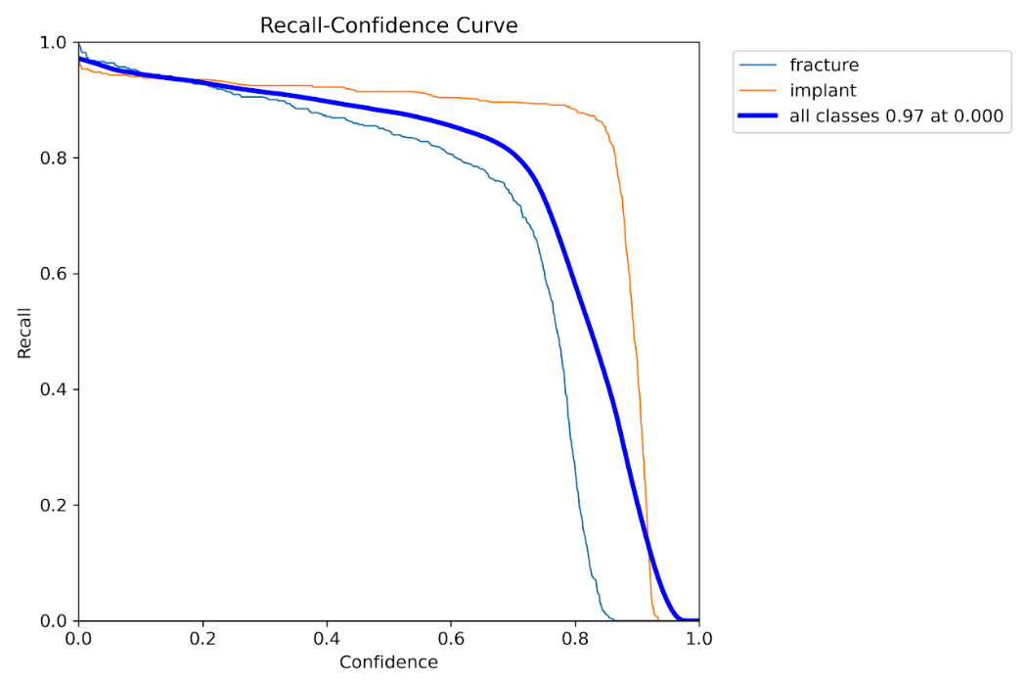
Figure 14: Precision- Recall Curve

Figure 14 depicts the Recall–Confidence Curve, which highlights the model’s ability to maintain high sensitivity across thresholds. Even at a confidence threshold of 0.70, recall remains around 80%, showing that YOLOv8 continues to detect the majority of true positives even under stricter conditions.
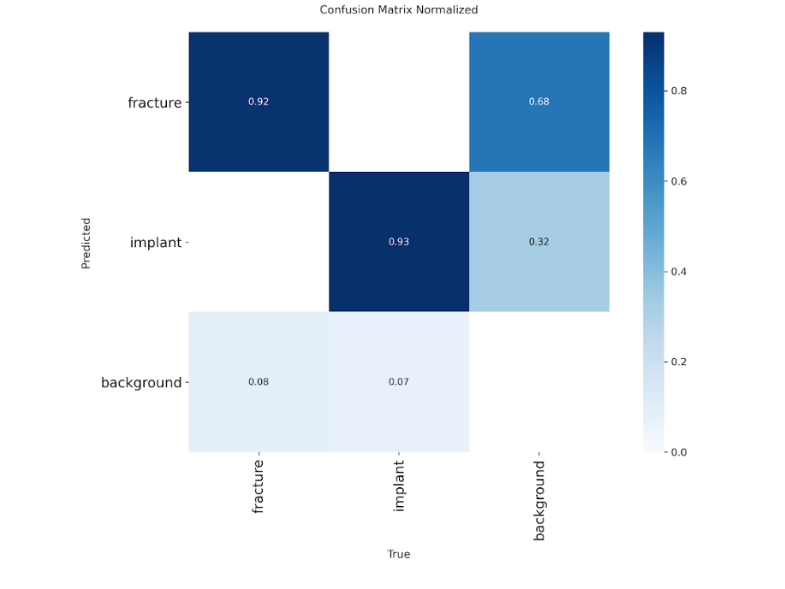
Figure 15: Confusuion Matrix
Figure 15 provides the Confusion Matrix, offering per-class evaluation. The model achieves strong recall values of 92% for fractures and 93% for implants, demonstrating that fine-tuning successfully preserved the detection accuracy of both targets.

- DISCUSSION
Why GAN Failed?
The GAN-founded fracture location technique encountered a number of difficulties. First, medical X-rays, particularly pediatric wrist radiographs, harbor very subtle fractures with small texture variations. GANs, especially the inpainting ones, prefer paying attention to reconstructing visually coherent bone patterns instead of emphasizing tiny structural defects. This led to the generator sometimes "smoothing out" fracture areas instead of bringing them out. GAN is prone to fluctuating loss balance and training stability and mask creation. The GAN was not able to persistently reconstruct healthy bone structures, and its localization accuracy was less than object detection approaches.
Why YOLO Succeeded?
The YOLOv8 method proved to perform much better on detecting fracture and implant from the wrist X Rays as YOLO directly learns the spatial structure instead of reconstruction like GAN’s. When compared to the GAN architecture this model showed increased precision and accuracy and also learnt fracture and implant patterns from wide range of X Rays.
Clinical Relevance and Limitations
Clinically, real time detection and localisation of YOLOv8 accurately is of great use especially in medical field. This will help in faster detection of fractures or implants and reduce the delay in diagnostics and help in forming a bridge between the radiologists and AI. But there are limitations to this too, the model fully depends on the dataset provided any new patterns or structures won’t be identified by the model which will affect the clinical. In the other hand , GAN although with its limitations will come in handy when there is no labelled data so can be used for unsupervised learning approach.
- CONCLUSION
The project began with GAN-based image inpainting solution, comparing PatchGAN, U-Net, and HD-UNet generators to restore masked wrist X-ray areas. Although U-Net was the most successful of the three, outputs were still blurry, missing fine anatomical details, and tended not to restore subtle fracture lines or to appropriately handle implants. HD-UNet marginally restored better structure but was marred by over-smoothing and misidentification of metal implants as bone continuity. In general, GAN approaches were found to be unstable for stable fracture localization because of the faintness of fractures, imbalance in classes, and the indirect nature of detection in the inpainting task.
Switching to a YOLOv8-derived direct detection method substantially enhanced performance. The model obtained a final mAP@0.5 of ~0.74, with well-balanced precision over fracture, healthy, and implant classes, and good recall for the detection of fractures. Box regression, classification, and DFL loss curves all displayed smooth convergence without instability, which indicates stable learning. The confusion matrix indicated high fracture detection ability with most of the misclassifications being between implants and healthy images as a result of visual similarity in some X-ray areas.

REFERENCES

- Pundir, B. S., Kumar, R., Gupta, M., & Obaid, A. J. (2024, June). Synthetic Image Generation for Improved Detection of Bone Defects Using GAN. In 2024 15th International Conference on Computing Communication and Networking Technologies (ICCCNT) (pp. 1-5). IEEE.
- Tabarestani, S. S., Aghagolzadeh, A., & Ezoji, M. (2021, December). Bone fracture detection and localization on mura database using faster-rcnn. In 2021 7th International Conference on Signal Processing and Intelligent Systems (ICSPIS) (pp. 1-6). IEEE.
- Joshi, D., Singh, T. P., & Joshi, A. K. (2022). Deep learning-based localization and segmentation of wrist fractures on X-ray radiographs. Neural Computing and Applications, 34(21), 19061-19077.
- Alwzwazy, H. A., Alzubaidi, L., Zhao, Z., & Gu, Y. (2025). FracNet: An end-to-end deep learning framework for bone fracture detection. Pattern Recognition Letters, 190, 1-7.
- Ju, R. Y., Chien, C. T., Xieerke, E., & Chiang, J. S. (2024). Pediatric Wrist Fracture Detection Using Feature Context Excitation Modules in X-ray Images. arXiv preprint arXiv:2410.01031.
- Nagy, E., Janisch, M., Hržić, F. et al. A pediatric wrist trauma X-ray dataset (GRAZPEDWRI-DX) for machine learning. Sci Data 9, 222 (2022). https://doi.org/10.1038/s41597-022-01328-z
- https://stanfordmlgroup.github.io/competitions/mura/
- Thian, Y. L., Li, Y., Jagmohan, P., Sia, D., Chan, V. E. Y., & Tan, R. T. (2019). Convolutional neural networks for automated fracture detection and localization on wrist radiographs. Radiology: Artificial Intelligence, 1(1), e180001.
- Ju, R. Y., & Cai, W. (2023). Fracture detection in pediatric wrist trauma X-ray images using YOLOv8 algorithm. Scientific Reports, 13(1), 20077.
- Suzuki, T., Maki, S., Yamazaki, T., Wakita, H., Toguchi, Y., Horii, M., ... & Ohtori, S. (2022). Detecting distal radial fractures from wrist radiographs using a deep convolutional neural network with an accuracy comparable to hand orthopedic surgeons. Journal of digital imaging, 35(1), 39-46.
- Zhang, Z., Hui, X., Tao, H., Fu, Z., Cai, Z., Zhou, S., & Yang, K. (2025). Application of artificial intelligence in X-ray imaging analysis for knee arthroplasty: A systematic review. PLoS One, 20(5), e0321104.
- Wu, X., Zhang, Y., & Li, Z. (2022). YOLOv5-based automated fracture detection in musculoskeletal radiographs. Journal of Medical Imaging, 9(4), 041301.
- Li, X., Zhang, Y., & Wang, L. (2023). Comparative study of object detection frameworks for bone fracture detection. Journal of Medical Imaging, 10(3), 031302.

APPENDIX
Code:(FOR YOLO)
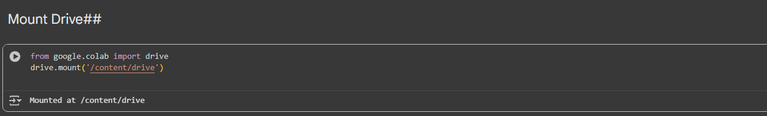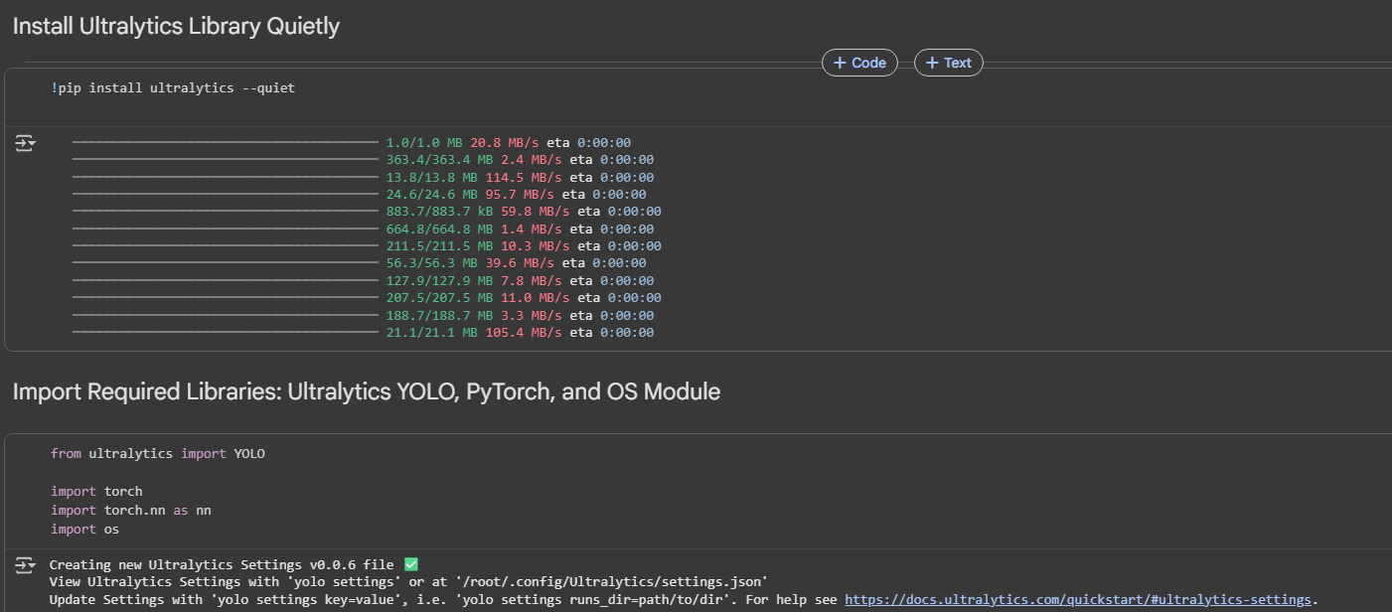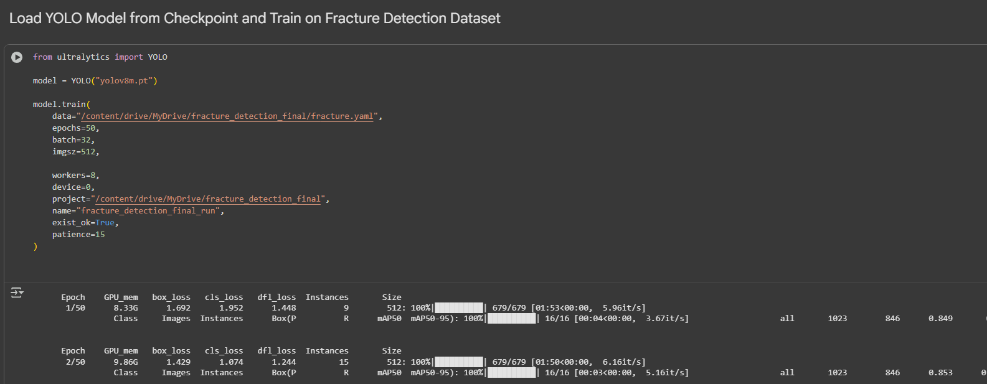

Fracture.yaml
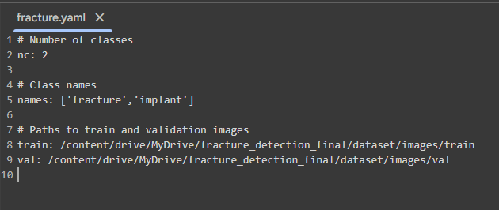

Code: (FOR GAN)
Dataset.py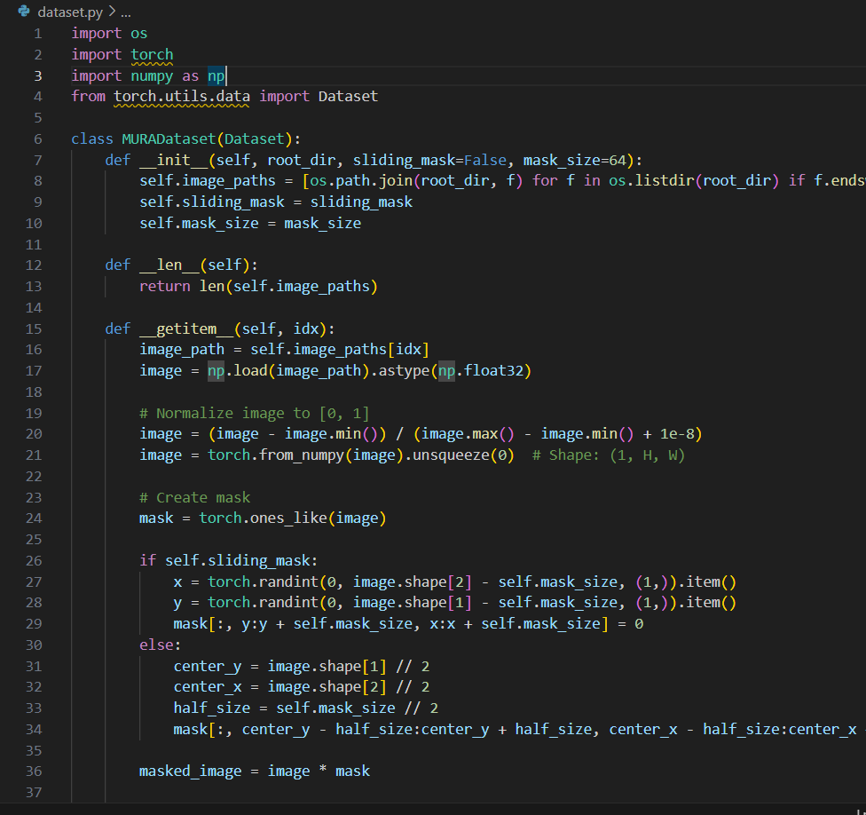
Model.py
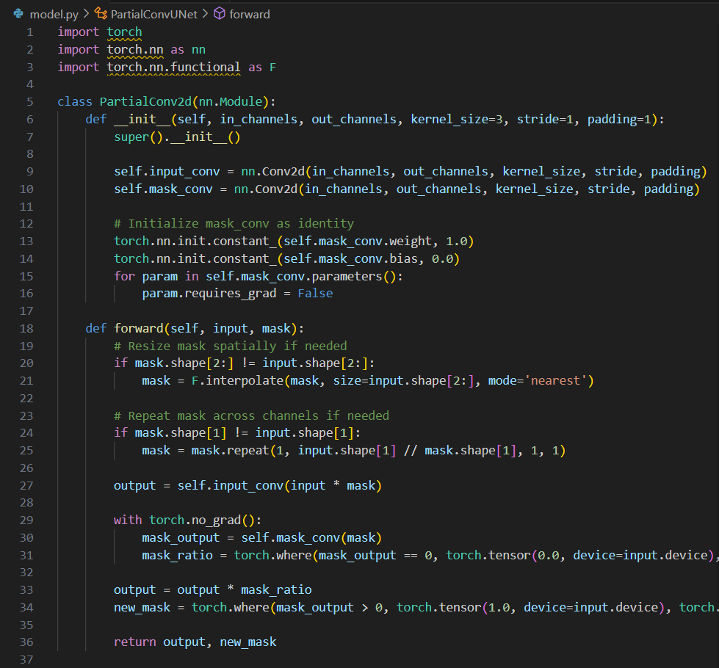

Train.py
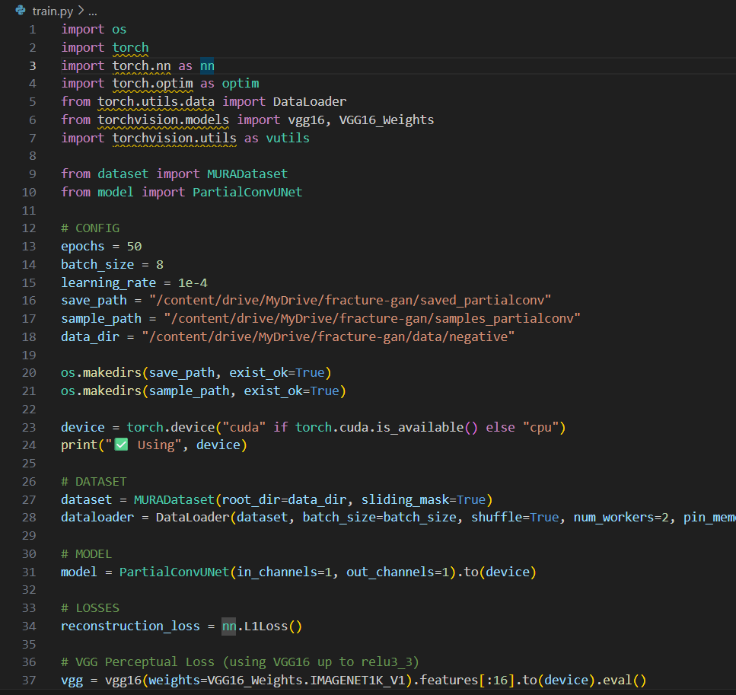
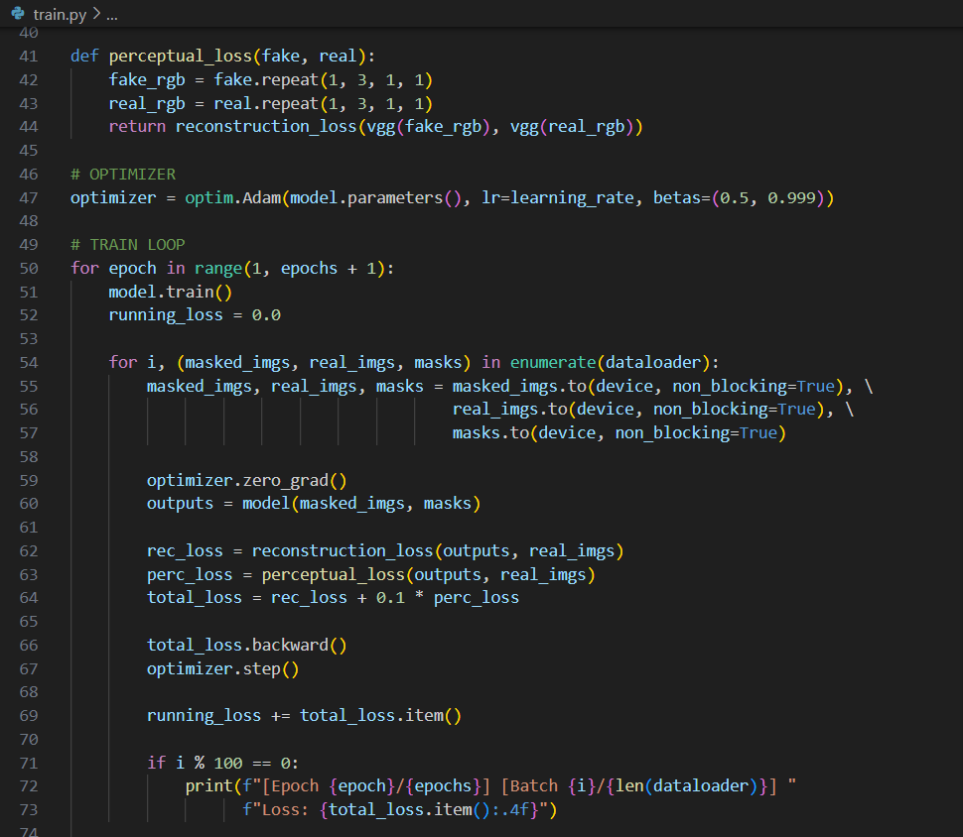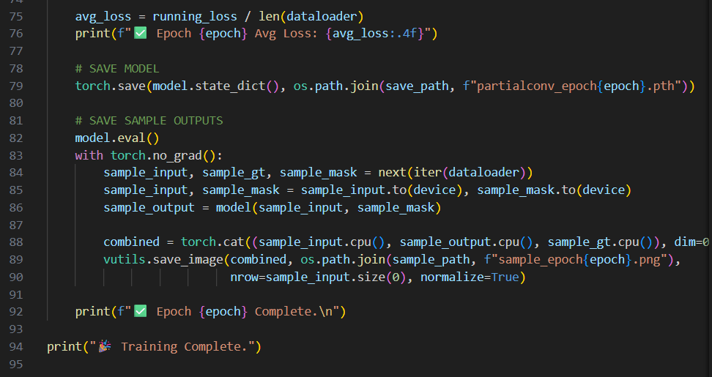

App.py
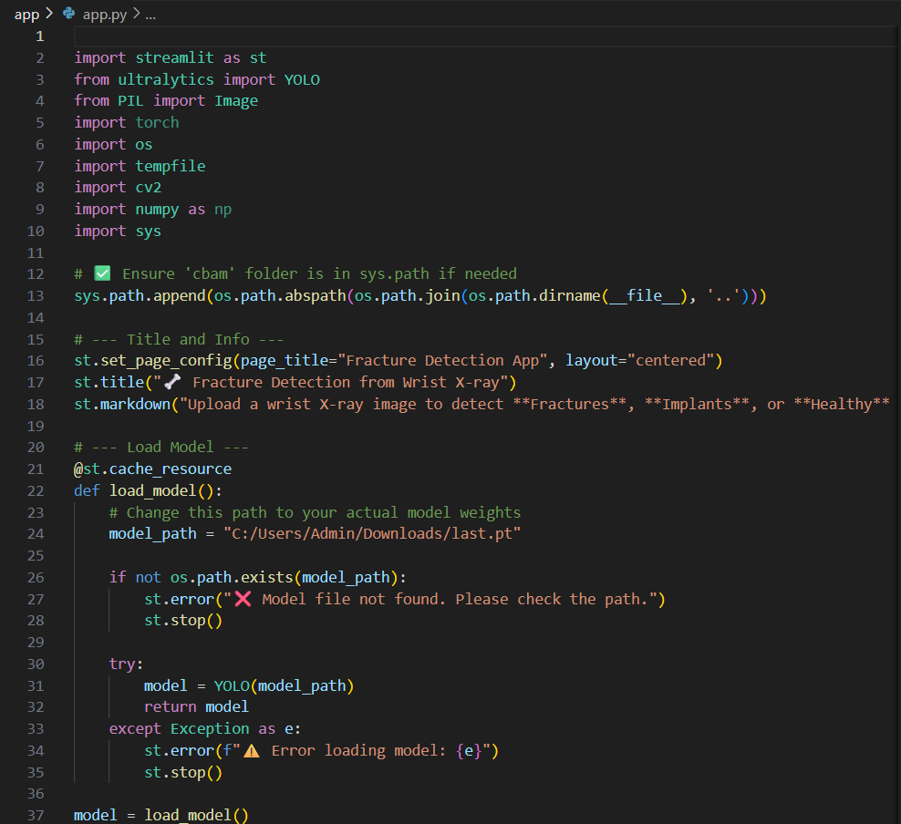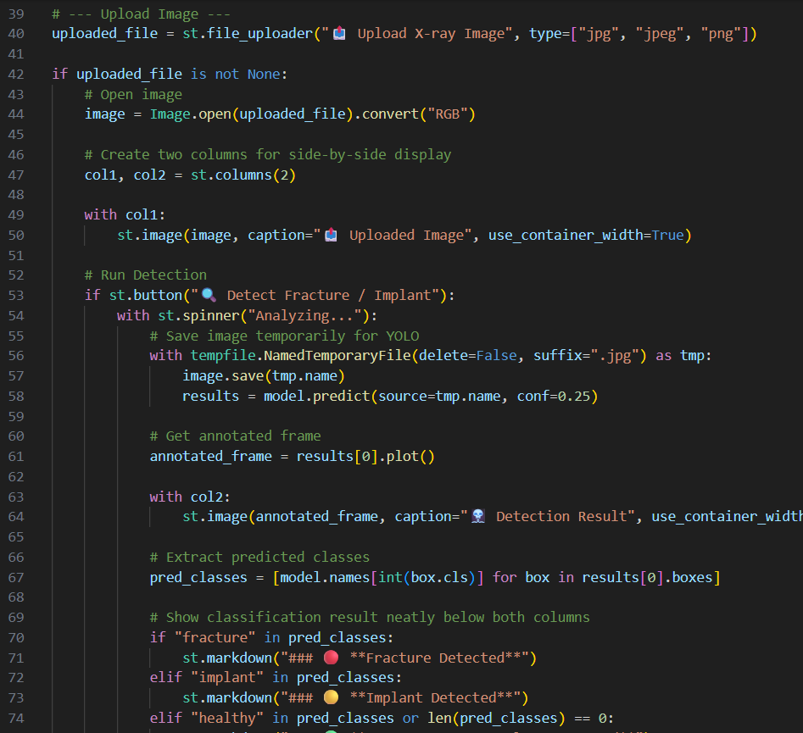
Streamlit Application for Real-time Fracture Detection
